BRILLIANT BOOKS FOR 6-9 YEAR-OLDS
•
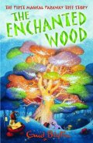

The Enchanted Wood
by Enid Blyton
Egmont
When Joe, Beth and Frannie move into a new home, they discover a mysterious wood on their very doorstep.

• 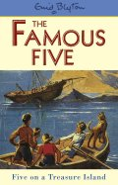

Five on a Treasure Island
by Enid Blyton
Hodder
Meet Enid Blyton's most famous characters - Julian, Dick, Anne, George and of course the ever-loyal Timmy the dog

• 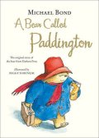

A Bear Called Paddington
by Michael Bond
HarperCollins Children's Books
Paddington, the brown bear from darkest Peru, is found by the Brown family on Paddington Station with his hat, duffel coat and marmalade sandwiches.

• 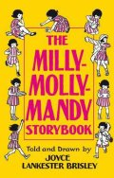

The Milly-Molly-Mandy Storybook
by Joyce Lankester Brisley
Macmillan
Milly-Molly-Mandy lives with her mother, father, uncle, aunt, grandmother and grandfather in a 'nice white cottage with a thatched roof'.

• 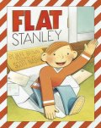

Flat Stanley
by Jeff Brown
Egmont
Stanley Lambchop wakes up one morning to find he is only half an inch thick

• 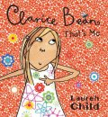

Clarice Bean, That's Me
by Lauren Child
Orchard Books
Clarice Bean gives us a snapshot of her life and family in the book that launched a bestselling series.

• 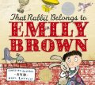

That Rabbit Belongs to Emily Brown
by Cressida Cowell
Orchard Books
Emily and her toy rabbit, Stanley, love to go on adventures together.

• 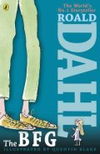

The BFG
by Roald Dahl
Puffin
The BFG stands for Big Friendly Giant, who unexpectedly spirits a little girl named Sophie out of bed, and into the land of the child-eating giants.

• 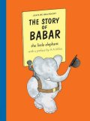

The Story of Babar
by Jean De Brunhoff
Egmont
' In the great forest, a litle elephant was born. His name was Babar...'
• 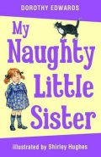

My Naughty Little Sister
by Dorothy Edwards
Egmont
This affectionate portrait of family life is the story of a naughty three-year-old sister who is obstinate, inquisitive and full of mischief.

• 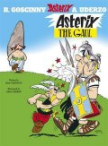

Asterix the Gaul
by René Goscinny
Orion
In a tiny corner of Brittany, one small village of indomitable Gauls hold out against the almighty, all-conquering Romans.

• 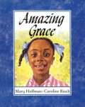

Amazing Grace
by Mary Hoffman & Caroline Binch
Frances Lincoln
This classic story clearly communicates an inspiring message that anything is possible
• 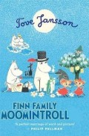

Finn Family Moomintroll
by Tove Jansson
Puffin Books
Moomintroll is cheerful and chubby and lives in the magical Moominvalley with his mother, Moominmamma, his father, Moominpappa and all of their friends.

• 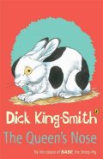

The Queen's Nose
by Dick King-Smith
Puffin
Harmony's Uncle Ginger sends her on a treasure trail - which ends in finding a 50p piece.

• 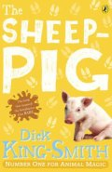

The Sheep-Pig
by Dick King-Smith
Puffin
When Farmer Hogget wins a piglet at the fair, he is amazed that Fly, his sheep-dog, welcomes him as one of her own pups.
• 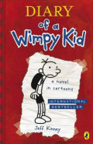

Diary of a Wimpy Kid
by Jeff Kinney
Puffin
Greg Heffley is a normal American kid, albeit one with a habit of getting into (and out of) trouble.

• 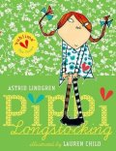

Pippi Longstocking
by Astrid Lindgren
Oxford University Press
Follow Pippi Longstocking on her amazing adventures as she moves into Villa Villekulla with a horse, a monkey, and a big suitcase of gold coins.

• 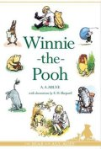

Winnie-the-Pooh
by A A Milne
Egmont Books
No child's library could be complete without A A Milne's stories about Pooh, Christopher Robin and their friends in the Hundred Acre Wood.
• 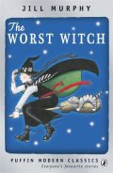

The Worst Witch
by Jill Murphy
Puffin
Long before Harry Potter first went to Hogwarts, trainee witch Mildred Hubble embarked on life at Miss Cackle's Academy for Witches...

• 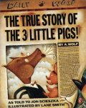

The True Story of the Three Little Pigs
by Jon Scieszka & Lane Smith
Puffin
What really happened to the three little pigs and the big bad wolf? Find out the truth in this hilarious picture book.

• 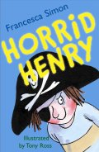

Horrid Henry
by Francesca Simon & Tony Ross
Orion Children's Books
Stories about naughty characters have been told for centuries, and Horrid Henry is a modern-day rogue in the tradition of Dennis the Menace and Just William.
• 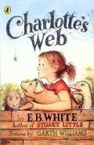

Charlotte's Web
by E B White
Puffin
This is the tale of how a little girl named Fern - with the help of a friendly talking spider called Charlotte - saved her pig, Wilbur, from the usual fate of nice fat little pigs.

• 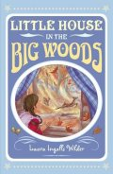

Little House in the Big Woods
by Laura Ingalls Wilder
Egmont
Inside the little house live the Ingalls family: Ma, Pa, Mary, Laura and baby Carrie.
• 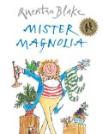

Mister Magnolia
by Quentin Blake
Red Fox
Mr Magnolia has many things - but only one boot

