BRILLIANT BOOKS FOR 0-6YEAR-OLDS

- 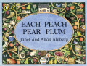

Each Peach Pear Plum
by Janet & Allan Ahlberg
Puffin
This classic book from author and illustrator team Janet and Allan Ahlberg is a real favourite with families

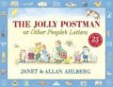

The Jolly Postman or Other People’s Letters
by Janet & Allan Ahlberg
Puffin
Brilliantly designed with lots of little details to spot, this old favourite will be enjoyed time and time again
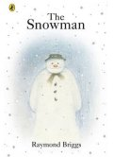

The Snowman
by Raymond Briggs
Puffin
James builds a snowman in the garden, then wakes up in the night to find that it has come to life.

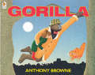

Gorilla
by Anthony Browne
Walker Books
Hannah's favourite animals in the whole world are gorillas, but her dad is always too busy to take her to the zoo.

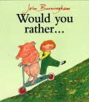

Would You Rather?
by John Burningham
Jonathan Cape
Would you rather drink snail squash or eat mashed worms? Help a witch make stew? Tickle a monkey?

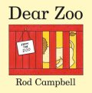

Dear Zoo
by Rod Campbell
Campbell Books
This appealing story, in lift-the-flap, board-book format has been a favourite with toddlers ever since it was first published in 1982.

- 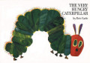

The Very Hungry Caterpillar
by Eric Carle
Puffin
Eric Carle's The Very Hungry Caterpillar deserves its reputation as a much-loved classic.
- 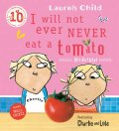

I Will Not Ever Never Eat a Tomato
by Lauren Child
Orchard Books
Charlie tricks his younger sister, Lola - an extremely fussy eater - into eating all her least favourite foods.

- 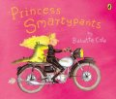

Princess Smartypants
by Babette Cole
Puffin
Princess Smartypants does not want to get married. She enjoys being a Ms. But being a rich and pretty princess means that all the princes want her to become their wife.

- 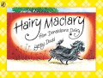

Hairy Maclary from Donaldson's Dairy
by Lynley Dodd
Puffin
This hilarious rhyming story follows Hairy Maclary from Donaldson's Dairy, as he sets off for a walk in town

- 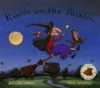

Room on the Broom
by Julia Donaldson and Axel Scheffler
Macmillan Children's Books
From former Children's Laureate Julia Donaldson and longtime collaborator Axel Scheffler comes this much-loved tale about a witch and her gang of friends.

- 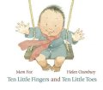

Ten Little Fingers and Ten Little Toes
by Mem Fox & Helen Oxenbury
Walker Books
This charming first book is perfect for new arrivals.
- #

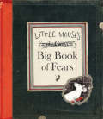

Little Mouse's Big Book of Fears
by Emily Gravett
Macmillan Children's Books
Little Mouse is scared of most things, from creepy crawlies and loud noises, to getting lost.

- 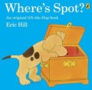

Where's Spot?
by Eric Hill
Puffin
This adorable picture book about Spot the dog is the first in the Spot series

- 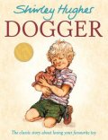

Dogger
by Shirley Hughes
Red Fox
When Dave loses his favourite toy, Dogger, he is desolate.

- 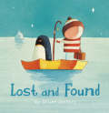

Lost and Found
by Oliver Jeffers
HarperCollins Children's Books
Once there was a sad, lonely penguin who appeared at the door of a young boy. The boy decided he must be lost, so he set off to find his home.
- 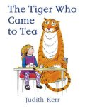

The Tiger Who Came to Tea
by Judith Kerr
HarperCollins Children's Books
Sophie and her Mummy are having tea in the kitchen when in walks a hungry tiger who asks to stay to tea.

- 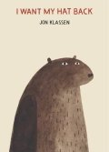

I Want My Hat Back
by Jon Klassen
Walker Books
A bear sets out in search of his hat - he loves his hat and he wants it back

- 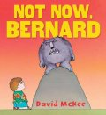

Not now, Bernard
by David McKee
Andersen
The classic tale of Bernard, whose distracted parents fail to notice that their son has been eaten and replaced by a monster.
- 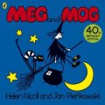

Meg and Mog
by Helen Nicholl & Jan Pienkowski
Puffin
In this the first story about much-loved characters Meg the witch and Mog her cat, the pair go off to a wild Hallowe'en party with all the other witches

- 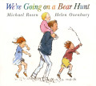

We're Going on a Bear Hunt
by Michael Rosen & Helen Oxenbury
Walker Books
Follow a father and his family as they go out in search of a bear.

- 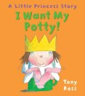

I Want My Potty!
by Tony Ross
Andersen Press
The Little Princess hates nappies, and thinks there must be something better.

- 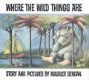

Where the Wild Things Are
by Maurice Sendak
Red Fox
First published in 1963, this classic picture book will fascinate both children and adults, evoking the fierce intensity of childhood
- 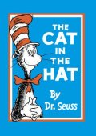

The Cat in the Hat
by Dr Seuss
HarperCollins Children's Books
When Sally and her brother are left alone on a rainy day, they think they are in for a dull time - but then the Cat in the Hat appears.

- 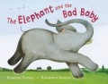

The Elephant and the Bad Baby
by Elfrida Vipont & Raymond Briggs
Puffin
One day, an elephant offers a baby a ride through the town, and the set off on a great adventure.

